
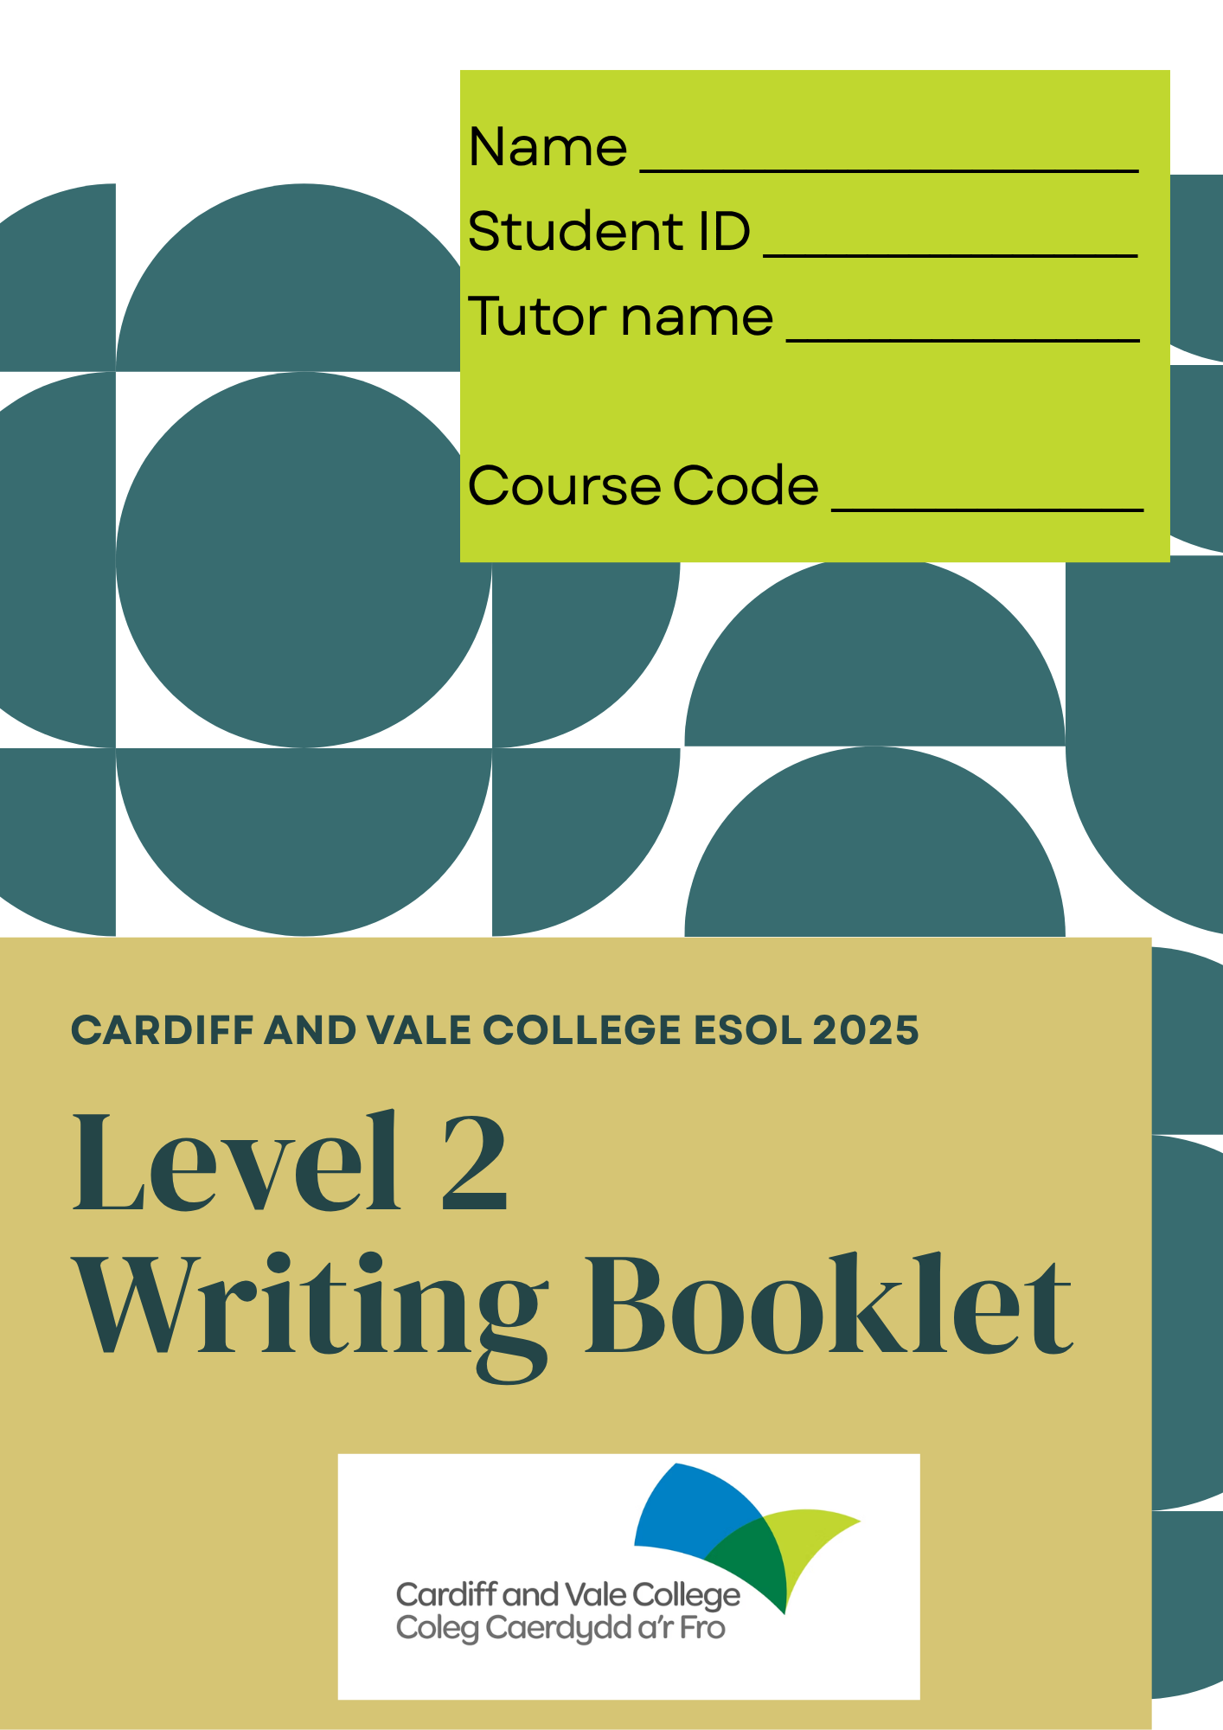
Acknowledgements:
Extra special thanks to teachers Rachael Robertson and Rio Judson.
Copyright CW 2025©

Contents
Contents:
Topic | Page
3.1 Form Filling | 6
1.1 Planning | 18
2.1 Purpose | 24
2.2 Register | 30
2.2 Tenses | 34
2.3 Passive Voice | 37
2.3 The Structure of a Paragraph | 39
2.3 Topic Sentences | 41
2.3 Supporting Sentences | 46
2.3 The Concluding Sentence | 49
2.3 Discourse Markers | 51
2.4 Simple Sentences | 57
2.4 Compound Sentences | 59
2.4 Complex Sentences | 64
2.4 Using Sentence Variety | 72
2.5 Correct Punctuation | 74
2.6 Spelling | 78
Further Practice: Task 1 Form | 79
Further Practice: Task 2 Formal Letter | 82
Further Practice: Task 3 Article | 87
Further Practice: Task 3 Opinion Essay | 89

Level 2 Writing Exam overview
Task 1 - Form with complex features (Guide time 30 minutes)
AC | Assessment Criteria | Evidence
3.1 | Complete a complex form | Section 1:  - All elements must be correct in capitals and lower case including full name, full address and postcode where required  - Follow the correct order for writing the address (building number, street name, town/city, postcode)
Section 2:
- All instructions in this section must be followed correctly (e.g. tick, delete, circle, underline)

Section 3:
- You must write at least 5 appropriate(correct) sentences in this section

Task 2 – Formal email or letter (220 words) (Guide time 50 minutes)
Task 3 – Article/essay (220 words) (Guide time 50 minutes)
AC​ | Assessment Criteria​ | Evidence​
1.1​ | Plan​ | - Show original ideas and details for all points of the question  - Show order of ideas & structure​
2.1​ | Purpose​ | - Correct format (email, letter, article etc.), style & length​  - Consistent and appropriate style  - Cover all the points from the question
2.2​ | Language​  ​ | - Correct register – formal, neutral or informal​  - Correct use of past, present and future tenses in at least 7 sentences  - Appropriate level of vocabulary (upper-intermediate)​
2.3​ | Structure​ | - Correct use of paragraphs or bullet points where appropriate  - Order is easy to follow  - Correct use of L2 discourse markers
2.4​ | Grammar​ | - Accurate grammar (tenses/subject-verb agreement)  - Use a range of simple/compound/complex sentences (with relative clauses and/conditional clauses as appropriate)  - Three correct complex sentences must be written.  - Pronouns must be used correctly
2.5​ | Punctuation​ | - Seven sentences must have correct punctuation  - Use a range of L2 punctuation appropriately (e.g. question marks, exclamation marks, colons, semi colons, speech marks, brackets, apostrophes, commas, bullet points, hyphens and dashes)
2.6​ | Spelling​ | - Majority of common words, technical words & relevant key words spelt correctly​
3.1​ | Fill in a form​ | Correct personal details​  Follow all instructions (delete, circle, tick, underline, etc.)​  Accurate sentences – relevant, coherent & correct​

- You must pass 5 out of 7 criteria to pass each task (2 and 3) but you must pass each criterion once across the whole writing paper.

Areas for improvement – ILP writing targets
Use this table to identify the areas you need to work on to improve your writing skills.
AC | SMART target | Learner check-in | Teacher feedback
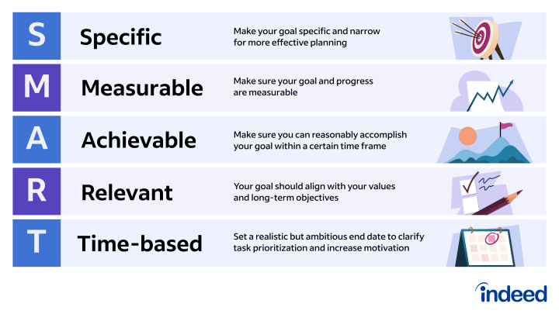

Writing AC 3.1: Form Filling
In the UK, filling in a form correctly is an essential skill to ensure the accurate processing of important applications and documents.
For the Level 2 writing exam, you must take care to answer all questions correctly with close attention to detail. One small error in sections 1 and 2 can cause a fail.
There can be up to three different kinds of section:
Section 1: Personal information Name, address, phone number, gender, DOB (date of birth), employment status, marital status, nationality, reference’s name (employer), their relationship to you, their contact details, etc.
Section 2: Close questions Tick √, circle, underline or delete as appropriate

Section 3: Open questions Answer with appropriate sentences, which means:
- relevant – directly answer the question
- coherent – make sense in context of your other responses
- accurate – are correct grammatical sentences at level

Be careful – don’t make these mistakes!
Section 1 Accuracy & order of address, precise use of capital & lower-case letters, vocabulary for job title v. occupation, qualifications, DOB, gender, status, etc.
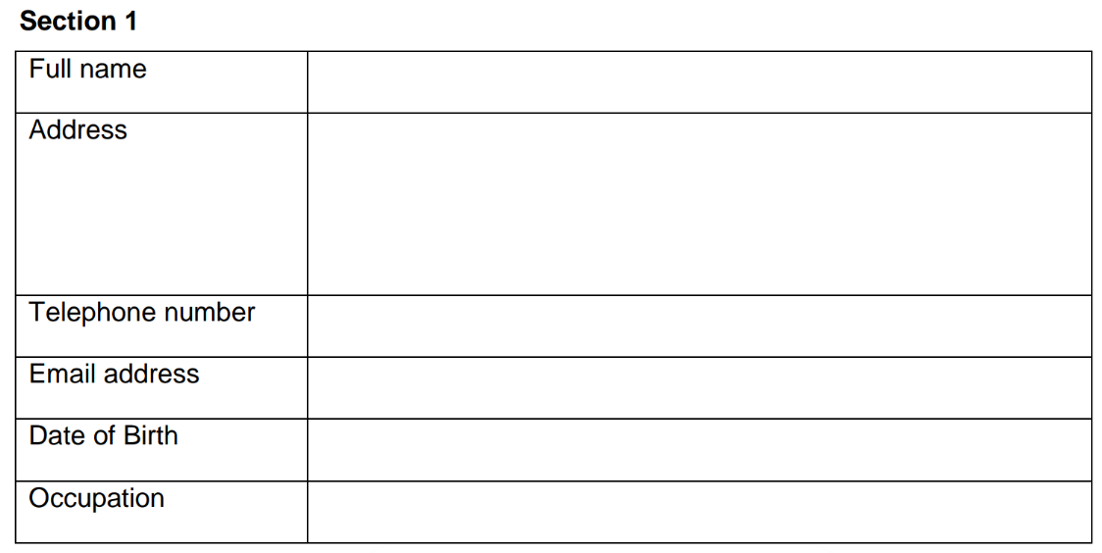
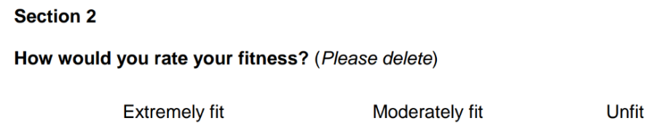
Section 2 Each question might require a different type of response, as listed above:

Section 3
  - Only those sentences that directly answer the question can be counted = relevant.
  - The responses need to fit in relation to other sections (i.e., if you gave a restaurant review 5 out of 5 stars earlier, your sentences should be positive about the quality) = coherent.
  - Sentences need to be grammatically correct. However, to improve your chances at success in this section, you are advised to use simple sentence structures. This will play it safe and count more sentences in total giving you better chances.

  - Sentences should be Level 2 (upper-intermediate) in terms of level of vocabulary, verbs use, etc., even if using simple sentence structures.
  - Remember, the context is key. Read the question carefully.
  - If it is an application form, you can make up details that match the question. For example, if you are asked to apply to be a PE Teacher (physical education) but you don’t like sports, you can pretend to have competed in the National Championships winning a gold medal, led a volleyball team as captain, and/or earned a PGCE qualification in teaching sport if you like. That is ok.

Task 1: Fill your personal details in the table below.

Name: |  | Surname:
Address:
Post code: |  | Phone:
DOB: |  | Gender:
Marital status: |  | NOK:
Employment status: |  | Job title:
Nationality: |  | Ethnicity:
First language: |  | Dietary preferences:

Form Practice 1
Task 2: Complete the form below
You recently attended a musical theatre production at the Wales Millennium Centre in Cardiff Bay. Afterwards, you were asked to complete this survey.


Wales Millennium Centre: Customer Feedback Form
Which of the following shows did you see on your visit today? (Tick one.)
□ Branwen: Dadeni □ Hamilton □ Mamma Mia
□ Cats □ Les Miserables □ The Lion King

Which performance did you watch? (Please underline.)
14:00 showing 20:00 showing

How often do you attend the theatre? (Delete as appropriate.)
Never Rarely Sometimes Often Always

On a scale of 1 (low) to 10 (high), how much did you enjoy today’s performance? (Please circle.)
1 … 2 … 3 … 4 … 5 … 6 … 7 … 8 … 9 … 10
We value your feedback! Please let us know what you enjoyed about your visit today.
________________________________________________________________________________________________________________________________________________________________________________________________________________________________________________________________________________________________________________________________________________________________________________________________________________________________________________________________________________________________________________________________________________________________________________________________________________________________________________________________________________________________

Please let us know how we can improve.
________________________________________________________________________________________________________________________________________________________________________________________________________________________________________________________________________________________________________________________________________________________________________________________________________________________________________________________________________________________________________________________________________________________________________________________________________________________________________________________________________________________________________________________________________________________________________________


When answering the open questions, it can be helpful to rephrase the question in your response. Keep your response directly relevant instead of wandering off on a slightly different tangent.
For example: What was the purpose of your stay?
The purpose of my stay was…

Form Practice 2
Task 3: Complete the form below
Name
Address
Phone
Email address
Age
Allergies & medical needs
You are applying for a volunteer role with a charity that looks after wildlife in West Wales. In this position, you would live for four months on Skokholm Island helping the wardens manage the island and monitor the wild animals.


Section 1

Section 2
Are you a Welsh speaker? / Ydych chi'n siaradwr Cymraeg?
□ Yes, I am / Ydw
□ No, I’m not / Nac ydw
□ Not yet, but I’m willing to learn! / Ddim eto, ond dwi'n fodlon dysgu!

Do you have volunteering experience?
□ Yes, I do
□ No, I don’t

Do you have outdoor experience?
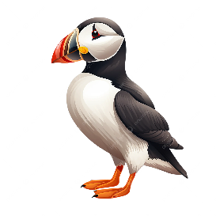
□ Yes, I do
□ No, I don’’t

Section 3
Why are you interested in volunteering with the Wildlife Trust?
________________________________________________________________________________________________________________________________________________________________________________________________________________________________________________________________________________________________________________________________________________________________________________________________________________________________________________________________________________________________________________________________________________________________________________________________________________________________________________________________________________________________________________________________________________________________________________________________________________________________________________________________________________________________________________________________________________________________________________________________________________________________________________________________________________________________________________________________________________________________________

What volunteering experience have you had previously?
______________________________________________________________________________________________________________________________________________________________________________________________________________________________________________________________________________________________________________________________________________________________________________________________________________________________________________________________________________________________________________________________________________________________________________________________________________________________________________________________________________________________________________________________________________________________________________________________________________________________________________________________________________
What environmental problems are important to you and why?
__________________________________________________________________________________________________________________________________________________________________________________________________________________________________________________________________________________________________________________________________________________________________________________________________________________________________________________________________________________________________________________________________________________________________________________________________________________________________________________________________________________

Name of referee
Job title
Relationship to you
Phone
Email

______________________________ ______________________________
Signature Date

Form Practice 3
Task 4: Complete the form below
You want to apply for a course at your local college. Please complete the application form below.


SECTION 1: Personal Details
Complete this section with your own details.
- Full name: ___________________________________________
- Address: ____________________________________________
- Postcode: ___________________________________________
- Email address: ________________________________________
- Telephone number: ____________________________________
- Date of birth: _________________________________________

SECTION 2: Choose the Correct Information
Tick, circle, underline or delete as instructed.
- What is your current situation?
☐ I am working full time
☐ I am working part time
☐ I am unemployed
☐ I am a student
- What course are you interested in?
☐ Business Administration
☐ Health and Social Care
☐ IT for Beginners
☐ English for Work
- When would you prefer to study?
☐ Morning
☐ Afternoon
☐ Evening
- Where would you prefer to study?
☐ Main Campus
☐ Online
☐ Community Centre
- Do you have any special support needs?
(Underline one):
Yes / No
If yes, please give details: ________________________________
- Are you eligible for funding?
(Delete one):
I am / I am not receiving any benefits.
I have / I have not lived in the UK for more than 3 years.

SECTION 3: Answer the questions in full sentences.
- Why would you like to join this course?

- What experience or qualifications do you have in this subject (if any)?

- What are your future goals after completing this course?

Form: Practice 4
Task 5: Complete the form below
Fill in the form for your friend Maria using the information below.
Maria Boyko is 23 years old and her birthday is 27th March. She loves yoga, swimming and riding horses every week. She is vegetarian and feels a healthy lifestyle is a top priority in her life, so she takes great care in terms of fitness and nutrition. She is currently studying ESOL Entry 3 at CAVC, while volunteering part-time in a charity shop in Cardiff. She aspires to become a pharmacist in the future and already has a Bachelor of Science degree in Chemistry from her home country. She resides at 88 Sunshine Place, Cardiff, CF21 5OK. She lives in a detached house on her own with two kittens whom she adores. She recently started running with a fun group of friends most mornings before classes start at college.

Section 1
Name |  | Surname
Address |  | DOB
 |  | Gender
 |  | Dietary Requirements
Post Code |  | Occupation

Section 2
How important is a healthy lifestyle to you? (Please delete as appropriate.)
Low importance Medium importance High importance

How often do you exercise? (Please circle.)
Never Hardly ever Sometimes Often

How healthy do you eat? (Please underline.)
Not healthy at all Somewhat healthy Extremely healthy
Section 3
Describe your current lifestyle. How do you take care of your health?
__________________________________________________________________________________________________________________________________________________________________________________________________________________________________________________________________________________________________________________________________________________________________________________________________________________________________________________________________________________________________________________________________________________________________________________________________________________________________________________________________________________________________________________________________________________________________________________________________________________________________________________________________________________________________________________________________________________________________________________________________________________________________________________________________________________________

What is your goal for the future and how have you been working towards it?
____________________________________________________________________________________________________________________________________________________________________________________________________________________________________________________________________________________________________________________________________________________________________________________________________________________


Writing AC 1.1: Planning


Advice: How to Write a Good Plan
1. Understand the Question
Before you start planning, ask yourself:
- Who am I writing to?
- What type of text is it? (e.g. letter, article, report)
- What do I need to include?
Tip: Highlight or underline key words in the task.
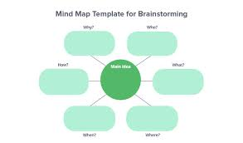
2. Use Bullet Points or a Mind Map
- Don’t write full sentences yet.
- Just jot down the main points you want to include.
- Use 3–5 bullet points for ideas.

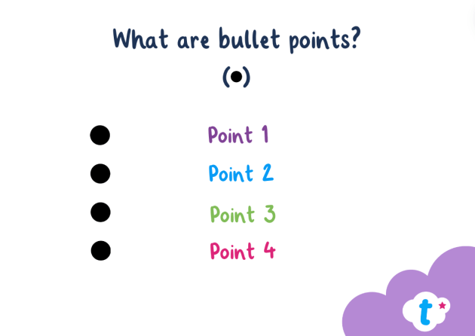
3. Decide the Structure
Think about paragraphs:
- Introduction: Say what the text is about
- Main points: One paragraph for each idea
- Conclusion (if needed): Final advice or summary
Use a simple layout:
Intro → Idea 1 → Idea 2 → Idea 3 → Conclusion

4. Add Examples or Details
In your plan, write short notes like:
- “Join library – free – meet people”
- “Park – walk dog – good for kids”
This will help you write more clearly and stay focused.

5. Check for Purpose and Tone
Ask yourself:
- Should it sound formal (e.g. letter of complaint)?
- Or friendly (e.g. advice article)?
Make sure your plan matches the tone.

Planning 1
Task 1: True or False Quiz - How to Write a Good Plan
Instructions: Read each sentence carefully. Decide if it is True or False. Correct the false ones.

- You should always write full sentences when making a plan.
🟩 True ☐ 🟥 False ☐

- A plan helps you organise your ideas before you start writing.
🟩 True ☐ 🟥 False ☐

- It’s a good idea to use bullet points or a mind map in your plan.
🟩 True ☐ 🟥 False ☐

- You don’t need to read the question carefully before planning.
🟩 True ☐ 🟥 False ☐

- In your plan, you should think about how many paragraphs your writing will have.
🟩 True ☐ 🟥 False ☐

- Your plan should include examples or short notes to help you remember details.
🟩 True ☐ 🟥 False ☐
- A good plan includes emojis and jokes to keep the examiner happy.
🟩 True ☐ 🟥 False ☐
- It's helpful to think about whether your writing should be formal or informal.
🟩 True ☐ 🟥 False ☐
- Planning wastes time and is not useful in the writing exam.
🟩 True ☐ 🟥 False ☐
- You should include your main ideas and supporting points in the plan.
🟩 True ☐ 🟥 False ☐

Planning 2
Task 2: Read the Task 2 Formal Letter below and complete the plan.
24 Greenhill Road
Manchester
M15 4QL
12 June 2025
Customer Services
Northern Rail
1 Mainline House
Leeds
LS1 4LT
Dear Sir or Madam,
I am writing to complain about a very disappointing train journey I experienced on 10th June 2025. I travelled on the 10:15 service from Manchester Piccadilly to Leeds, which was delayed by over two hours.
There were several issues during the journey. Firstly, there were no clear announcements or updates about the delay, and passengers were left confused and frustrated. Secondly, the toilet facilities on the train were out of order, which caused serious inconvenience on such a long and delayed journey.
Due to the delay, I missed an important job interview in Leeds. I had planned the journey carefully to arrive in plenty of time, but the disruption caused unnecessary stress and wasted both time and money.
I would like a full refund for my ticket and an apology for the poor service. I also hope that in future, your company will improve communication with passengers during delays.
Please contact me at the above address or by email at [your.email@example.com].
Yours faithfully,
[Your Name]

Now Complete the plan details below:
Who are you writing to?
☐ Friend
☐ Customer Services
☐ Local newspaper
Style:
☐ Informal
☐ Formal

Paragraph 1. Journey Details
- Date of journey: __________________________________________
- Time of train: _____________________________________________
- From: ______________________ To: ________________________
- Ticket/booking number (if known): ___________________________

Paragraph 2. What Went Wrong? (Write at least 2 problems)
- Problem 1: train delayed - no announcement or updates - no reason for delay

- Problem 2: toilets out of order

- (Optional) Problem 3: long delay

Paragraph 3. How Did It Affect You?
What happened as a result?
(e.g. missed an appointment, felt uncomfortable, wasted time)

Paragraph 4. What Do You Want the Company to Do?
(Choose 1 or more)
☐ Refund
☐ Travel voucher
☐ Apology
☐ Explanation
☐ Promise to improve service
What would you like to happen next?

Planning 3
Task 3: Read the Task 3 article below and write a plan.
Moving to a new area can be exciting but also a little stressful. If you’ve just arrived in Riverside, Cardiff, here are some tips to help you settle in and feel at home.

First, get to know your local area. Riverside is close to the city centre and Cardiff Castle, so it’s easy to explore on foot. There’s a lovely park by the River Taff and a regular farmers’ market on Sundays where you can buy fresh food and meet local people.

Second, make use of local services. The Riverside Library is a great place to borrow books, use the internet, and find information about events and courses. There are also community centres that offer English classes, advice sessions, and activities for families.

Third, try to meet people. You could join a local group, such as a walking club or a cooking class. Many people in Riverside are from different countries, so it’s a friendly and multicultural place where it’s easy to make new friends.

Finally, don’t be afraid to ask for help. Whether it’s a neighbour or a shop assistant, most people are happy to give directions or advice.

With time, you’ll feel confident and comfortable in your new community. Welcome to Riverside!

Write your plan here:

Planning 4
Task 4: Choose one of the following Task 3 questions and write a plan below:
  - Write an article giving advice to someone who wants to learn English in the UK.
What should they do to improve their English outside the classroom?

  - Write an article giving advice to someone starting their first job in the UK.
Include tips about communication, timekeeping, and workplace culture.

  - Write an article giving advice to a young person about how to stay safe and happy online.
Mention social media, online privacy, and screen time.

Write your plan here:

Writing AC 2.1: Purpose
Task 2 Writing Question (Formal Email)
Task 1: Read the exam question and email below then answer the following questions.
You are concerned about the amount of rubbish in the local parks. Write a formal email to a newspaper explaining the problem and saying what you think should be done.
(Write at least 220 words.)
To: editor@cardiffvoice.co.uk
Subject: Concern About Rubbish in Local Parks

Dear Editor,
I am writing to express my concern about the increasing amount of rubbish in our local parks in the Roath area. I believe this issue is not only damaging the environment, but it is also affecting the health and well-being of local residents.
Over the past few months, I have noticed large amounts of litter left on the grass, in the playgrounds, and along walking paths. This includes plastic bottles, takeaway containers, and even broken glass. Unfortunately, the bins are often overflowing or not emptied regularly, which makes the problem worse.
Many local families and children use these parks for exercise and relaxation. It is disappointing to see such beautiful spaces being treated with disrespect. I strongly believe that more should be done to keep our parks clean and safe for everyone.
Therefore, I would like to suggest more frequent bin collections, the installation of larger waste and recycling bins, and clear signs reminding people to dispose of their rubbish responsibly. Community clean-up events and school education programmes could also help raise awareness.
Thank you for your attention. I hope your newspaper can highlight this issue and help encourage positive change in our community.

Yours sincerely,
Aisha Khan
Cardiff resident

Comprehension Questions: Formal Email Style
- Who is the email addressed to?
- Why is it important to include the recipient’s email address and a subject line?
- What is the purpose of the email?
- Which two phrases show that this is a formal email?
- How does the writer open and close the email?
- What suggestions does the writer make to solve the problem?
- Why is it important to include a subject line in a formal email?
- What is the difference between “Yours sincerely” and “Yours faithfully”? Which one is used here, and why?
- What could you suggest if you were writing your own version of this email?

Task 2: Now write your own version of the email using your local area. Use the structure from the example as a model.

2.1 Article giving advice
Task 3: Read the exam question below then complete the following activities.
Write an article giving advice on how to stay motivated during your ESOL course.
(Write about 220 words.)

PART A: Gap-Fill Activity – Complete the Article Below
How to Stay Motivated During Your ESOL Course
Learning a new language can be exciting, but it can also be __________ at times, especially when progress feels slow or life gets busy.
(1 word – means “difficult or tiring”)
Here are some useful tips to help you stay __________ during your ESOL course.
(1 word – means “interested and enthusiastic”)
First, set clear __________ for yourself.
(1 word – what you want to achieve)
It could be passing your next exam, applying for a job, or speaking more confidently in class. When you have a goal, you are more likely to stay focused.
Second, try to practise a little every day. Even 10 minutes of reading or listening in English can make a big __________ over time.
(1 word – result or change)
It’s also helpful to study with a friend or classmate. You can quiz each other, share ideas, and support one another when things feel tough. This makes learning more fun and less __________.
(1 word – means “lonely”)
Don’t forget to celebrate your __________, no matter how small.
(1 word – achievements)
Finished a piece of writing? Learned five new words? Well done!
Finally, stay __________. Learning takes time, but every step you take brings you closer to your goals.
(1 word – means “positive and hopeful”)

PART B: Reflection Questions
- What is the purpose of the article?
- Is the tone formal or friendly? Give an example.
- What advice would you give to someone who feels demotivated in class?
- Can you think of a small goal to set this week?

Part C: Extension Task
Now write your own version of the article. Give it a title and include three useful tips for staying motivated. Use the structure and vocabulary from the gap-fill to help you.

2.1 Essay Style Article
Task 1: Read the exam question below then complete the following exercises.
Write an article giving your opinion on this statement:
“Young people spend too much time on screens and do not spend enough time outdoors.”
Give reasons and examples to support your view. (Write approx. 220 words)

Part A: Read the Paragraphs (A–D)
They are in the wrong order. Match each one to its correct place in the article (Introduction, Point 1, Point 2, or Conclusion).

Paragraph A
In my opinion, it’s not about removing screens completely, but about finding a healthy balance. Parents, schools, and communities can help by organising outdoor activities and encouraging screen-free time.

Paragraph B
On one hand, screens are a big part of everyday life. Teenagers often use them for studying, staying in touch with friends, or relaxing after school. Many young people also use apps to learn languages, create music, or develop skills. Not all screen time is bad.

Paragraph C
To conclude, screens are here to stay, but it’s important that young people are also given time and space to enjoy life outdoors.

Paragraph D
In today’s digital world, it is true that many young people spend a lot of time using screens – whether it’s mobile phones, tablets, or gaming consoles. But does this mean they are no longer spending time outdoors? I believe the answer is more complicated than a simple “yes” or “no.”

Part B: Match Each Paragraph to Its Role
Paragraph | Role in Article
D | Introduction
B | First main point
A | Second main point
C | Conclusion

Part C: Follow-Up Questions
- What is the writer’s overall opinion on the topic?
- Does the writer consider both sides of the argument? Give one example.
- Find two linking words or phrases used in the article.
- How does the article try to give advice or solutions?
- How is this article different from a letter or an email in terms of tone and structure?
- How does the writer give their own opinion?
- Why is it important to use paragraphs in this type of writing?
- If you wrote your own version of this article, would you agree or disagree? Why?

Writing AC 2.2: Register
What does “register” refer to in the use of English language?
Language register in English is the scale of formality we use when we write and speak.
We use different language registers for different types of writing, just as we speak differently to different people.

What Is Register?
Register is the level of formality you use in speaking or writing.
You choose formal or informal language depending on:
- Who you are speaking or writing to
- The purpose of the communication
- The situation (e.g. job interview vs chatting with a friend)

Formal Language (used in emails/letters to a company, job applications, complaints, articles, reports)
- Polite and professional
- Uses full sentences and correct grammar
- No slang
- Avoid contractions (e.g. I am not I’m). Some are ok in formal emails but not letters.
- More serious tone
Examples:
✔ I would like to express my concern.
✔ I am writing to request further information.
✔ Thank you for your assistance.

Informal Language (used in texts to friends, casual emails, messages, personal writing)
- Relaxed and friendly
- Uses everyday words, contractions, and sometimes slang
- Can include emojis or abbreviations
Examples:
✔ Hey! Just wanted to ask you something.
✔ I’m not sure what’s going on.
✔ Thanks a lot!

Task 1: Identify the Register
Write F for Formal or I for Informal.
- Could you please send me the details as soon as possible? ___
- What’s up? Long time no see! ___
- I am writing to apply for the position advertised. ___
- Can you give me a hand with this? ___
- Yours sincerely, ___
- Cheers! ___

Task 2: Match the Sentences
Match the informal sentences (1–5) with their formal equivalents (A–E).
Informal Sentences | Formal Equivalents
1. I need some info. | A. I am sorry to hear that.
2. Sorry to hear that. | B. I would be grateful if you could help.
3. Can you help me out? | C. I would like to request some information.
4. Thanks a lot. | D. I appreciate your support.
5. I’m writing to ask about… | E. I am writing to enquire about…

Task 3: Rewrite the Sentences
Rewrite the informal sentences in a more formal way.
- I wanna know when the class starts.
___________________________________________
- Can you send me the stuff?
___________________________________________
- I’m not happy with this.
___________________________________________
- Got your email, thanks.
___________________________________________

Task 4: Discussion or Pair Task
Work with a partner or in a small group. Discuss:
- When do you use formal language in your life?
- When do you use informal language?
- Why is it important to choose the right register?

Extension / Homework Task
Choose one writing task and write it in the correct register:
- Write a formal email to your tutor asking for help with your homework
- Write an informal email to a friend telling them about your weekend

Writing AC 2.2: Tenses
In the Level 2 writing exam you must show that you can write in a range of past, present and future tenses in at least seven sentences. Try to always include a range of tenses if possible.
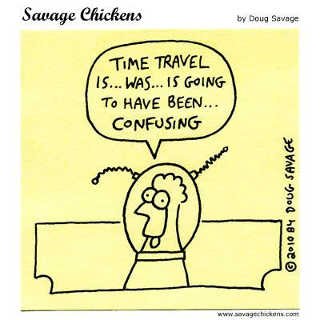

Here is a quick summary of the main tenses:
Simple Tenses
✔ Present Simple: I go to college every day.
✔ Past Simple: I went to the park yesterday.
Continuous Tenses
✔ Present Continuous: I am studying for my exam.
✔ Past Continuous: I was watching TV when you called.
Perfect Tenses
✔ Present Perfect: I have finished my homework.
✔ Present Perfect Continuous: I have been playing tennis for 5 years.
✔ Past Perfect Continuous: I had been painting the room for 3 days before I realised it was the wrong colour.
✔ Past Perfect: I remembered I had left my wallet at home.

Future Tenses
✔ Future with ‘will’: I will visit my friend tomorrow.
✔ Future with ‘going to’: I am going to cook dinner tonight.
✔Present Continuous for Future: I am having my hair cut tomorrow.
✔ Future Perfect: I will have completed the project by Friday.

Task 1: Identify the Tense
Read each sentence. Write which tenses are used. (e.g. Present Simple, Past Simple, Future ‘will’, etc.). There may be more than one in each sentence.
- She is watching a film right now. ____________________________
- We visited the museum last Saturday. ____________________________
- They have just arrived. ____________________________
- He had already left when you called. _________________________
- I will call you later. ____________________________
- He goes to the gym every Monday. ____________________________
- I was reading when the phone rang. ____________________________
- I am going to study engineering at university. ____________________________
- She’s been waiting for hours. _______________________________________
- I’ll have lived in Cardiff for 20 years next year.
Task 2: Fill in the Blanks
Complete the sentences using the correct tense of the verb in brackets.
- I __________ (eat) lunch at 12 o’clock every day.
- She __________ (not/finish) her homework yet.
- We __________ (watch) a movie when the lights went out.
- He __________ (go) to London next weekend.
- They __________ (play) football in the park yesterday.
- I __________ (study) English since January.
- You __________ (be) tired last night.
- He _____________ (wait) for 2 hours when she arrived.
- I ____________________ (finish) all my exams by the end of June.
- She _______________ (have) a bath when the doorbell rang.
Task 3: Write Your Own Sentences
Write one sentence for each tense:
- Present Simple: ____________________________________________________________________________
- Present Continuous: ____________________________________________________________________________
- Present Perfect: _____________________________________________________________________________
- Past Simple: ________________________________________________________________________________
- Past Continuous: _________________________________________________________________________________
- Past Perfect: _________________________________________________________________________________
- Past Perfect Continuous:
_________________________________________________________________________________
- Present Perfect:
________________________________________________________________________________
- Future (will):
_______________________________________________________________________________
- Future (going to):
_______________________________________________________________________________
- Present continuous for future:
______________________________________________________________________________
- Future Perfect:
______________________________________________________________________________

Writing AC 2.2 Passive Voice
Remember all tenses can be written in both the active and the passive voice.
Present
Verb tense | Active | Passive
Simple | I write | It is written
Continuous | I am writing | It is being written
Perfect | I have written | It has been written
Perfect Continuous | I have been writing | (not recommended)
Past
Verb tense | Active | Passive
Simple | I wrote | It was written
Continuous | I was writing | It was being written
Perfect | I had written | It had been written
Perfect Continuous | I had been writing | (not recommended)
Future
Verb tense | Active | Passive
Simple | I will write | It will be written
Continuous | I will be writing | It will be being written
Perfect | I will have written | It will have been written
Perfect Continuous | I will have been writing | (not recommended)

Task 1: Complete the sentences using the prompts: active.
- She ____________________________ (to ask, present perfect) for additional support in learning.
- They ____________________________ (to listen, past continuous) to music on their road trip.
- We ____________________________ (to study, future perfect continuous) Spanish for 6 months by the time we go travelling to Latin America.
- One of my friends ____________________________ (present perfect continuous) travelling in South-East Asia.
- My colleagues ____________________________ (to complete, future perfect) a collaborative project by the end of next month.

Task 2: Complete the sentences using the prompts: passive.
- Caerphilly Castle ____________________________ (to build, past simple) in 1290.
- The course ____________________________ (to complete, future perfect) by 2027.
- The match ____________________________ (to watch, present continuous) by millions of viewers.
- It ____________________________ (to show, present perfect) that apprenticeships are popular today.
- The student ____________________________ (to nominate, past perfect) for a national award
By the time she graduated.

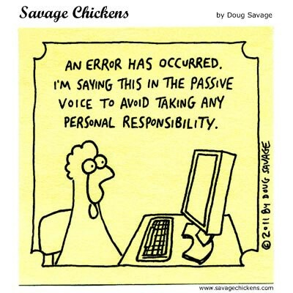

Writing AC 2.3: The Structure of a Paragraph

What is a paragraph?
A paragraph is a group of sentences about a single topic. A paragraph explains the writer’s main idea (most important idea) about the topic and supports it. At Level 2, a paragraph should be between four and six sentences long, depending on the task. Remember to leave a line between paragraphs:

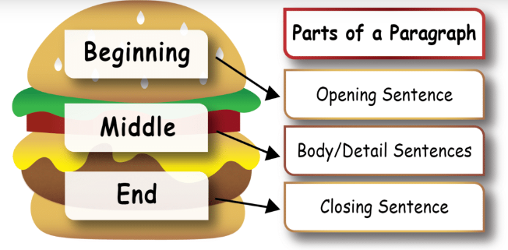

Follow these rules for perfect paragraphs.
- The paragraph must contain a topic sentence (a sentence that tells the reader what the paragraph is about).
- All other sentences should develop the topic sentence by giving further detail and evidence to support the idea.
- All the sentences within a paragraph should be about the same person, place, time or topic.
- The sentences should flow smoothly and logically.
- A concluding sentence may be added but is not essential.
- When the person, place, time or topic changes, you should start a new paragraph
- Every new paragraph should start on a new line.

Task 1: Read the following sentences. Underline the topic sentence, circle the concluding sentence and count the number of supporting sentences.
Paragraph 1
The weather in the UK is known for being unpredictable. In one day, it can be sunny in the morning, rainy in the afternoon, and cloudy by the evening. Because of this, many people carry an umbrella or a raincoat, just in case. Winters are usually cold and wet, while summers can be warm but short.
Although the weather can be frustrating, it is a common topic of conversation among British people. Many visitors are surprised by how quickly it can change. Overall, the British weather is something everyone learns to live with.

Number of supporting sentences: ______________________

Paragraph 2

Public transport in the UK is used by millions of people every day. The most popular types of public transport are buses, trains, and the underground in London. Many people use buses for short journeys around towns and cities. Trains are faster and are used to travel between cities, although they can be expensive. In London, the Underground (also called the Tube) is a quick way to travel around the city. Public transport is convenient but sometimes delayed. In general, public transport helps people travel easily across the UK.

Number of supporting sentences: ______________________

Paragraph 3

British food has changed a lot over the years. Traditional meals like fish and chips or roast dinners are still popular with many families. However, the UK is now home to many different cultures, and this has influenced the food. You can find Indian curries, Chinese noodles, Italian pasta, and many other international dishes. People enjoy trying new foods, especially in big cities like London, Manchester, and Birmingham. As a result, British food today is a mix of old traditions and modern tastes.

Number of supporting sentences: ______________________

Task 2: The following sentences are parts of a paragraph, but they are not in the correct order. Number the sentences and identify them as:

- topic sentence
- supporting sentences
- concluding sentence

- Sports are also popular, especially football, rugby, and cricket.
- For example, some people like to go for walks in the countryside or along the coast.
- Overall, there are many ways to enjoy free time in the UK.
- However, others prefer watching TV, reading books, or playing video games at home.
- People in the UK enjoy a variety of free time activities.
- Furthermore, many people also visit pubs or cafes to relax with friends.
- What people do in their free time depends on their age, interests, and where they live.

Write the paragraph in the correct sentence order below

Writing AC 2.3 Topic Sentences
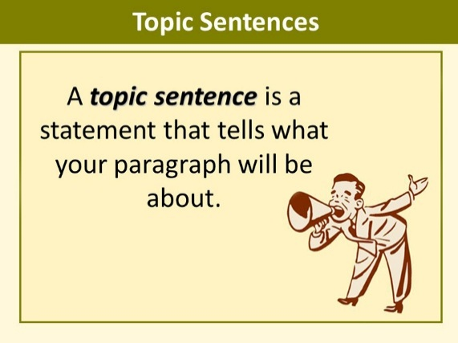
A topic sentence, is the most important sentence in a paragraph. The topic sentence is usually the first sentence in a paragraph - although it doesn't always have to be. However, this is the clearest way to present your points.
Purpose of the Topic Sentence
A topic sentence tells what the rest of the paragraph is about. All sentences after it have to give more information about the sentence, prove it by offering facts, examples or details.
Writing topic sentences (and controlling ideas)
When writing the topic sentence, try to state the main point of the paragraph as clearly and as accurately as possible. There are two parts to every topic sentence: a topic and a controlling idea.
- The topic is placed at the start of the sentence. It states the subject (topic) of the paragraph. It is what the paragraph is about.

- The controlling idea ‘controls’ everything else in the paragraph; it indicates what you want to say about the topic. It shows the direction the paragraph will take.

e.g. “Social media has made communication easier in recent years.”

Topic = social media Controlling idea = it has made communication easier in recent years

Task 1: Read the following three topic sentences. Each one has the same topic but a different controlling idea. Circle the topic and identify the controlling idea in each.

- Life in the UK can be expensive, especially in big cities like London.
- Life in the UK offers many cultural experiences, such as museums, festivals, and historic sites.
- Life in the UK can be challenging for newcomers who are learning the language and adapting to a new system.

Task 2: Identify the topic and the controlling idea in each of the following topic sentences. Circle the topic and underline the controlling idea.

- Public transport in London is efficient but can be very crowded during rush hour.
- Mobile phones have changed the way people communicate and spend their time.
- Learning English opens up more job opportunities for people in the UK.
- Fast food is popular because it is cheap and convenient, but it is often unhealthy.
- Recycling helps protect the environment by reducing waste and saving energy.

Task 3: Complete the topic sentences by adding a controlling idea.

- Public transport in the UK __________________________________________________________ _.
- Learning English ____________________________________________________________________.
- The weather in Wales ________________________________________________________________.
- Watching the UK news ______________________________________________________________ .
- Shopping in local supermarkets ______________________________________________________.
- Finding a job in the UK ________________________________________________________________.
- Going to the GP _____________________________________________________________________.
- Living in a shared house ______________________________________________________________.
- Celebrating British festivals ___________________________________________________________.
- Using social media ___________________________________________________________________.

Task 4: Choose the best topic sentence for each paragraph.
Paragraph 1
Many people use buses to travel to work, school, or shops. Trains are faster and are often used for longer journeys, such as going from one city to another. In big cities like London, the Underground helps people move around quickly. Although delays can happen, most people find public transport useful and affordable.
Which sentence is the best topic sentence?
A) The UK has many good restaurants in big cities.
B) Public transport in the UK is a common way for people to travel.
C) Driving a car is the best way to travel in the countryside.

Paragraph 2
Many people enjoy roast dinners, especially on Sundays. Fish and chips are another traditional favourite, often eaten at the seaside. In addition to traditional food, British people also enjoy dishes from around the world, like Indian curries and Italian pizza. The UK is home to many cultures, and this is reflected in the food people eat every day.
Which sentence is the best topic sentence?
A) Food in the UK includes both traditional and international meals.
B) Indian restaurants are popular in the UK.
C) British people eat a lot of fast food every week.

Paragraph 3
In summer, people like to visit parks, beaches, and festivals. In autumn, the leaves change colour and the weather becomes cooler. Winter is often cold and wet, and people stay indoors more. Spring brings flowers and longer days, which many people enjoy.
Which sentence is the best topic sentence?
A) British people don't like the weather.
B) Every season in the UK has something different to offer.
C) Spring is the best time to go on holiday.

Paragraph 4
Many students want to improve their English to get a better job. Some people study English to help their children with schoolwork. Others need it for daily tasks like shopping, travelling, or visiting the doctor. Speaking and understanding English can make life much easier in the UK.
Which sentence is the best topic sentence?
A) People study English for many different reasons.
B) Studying grammar is very important.
C) The English language is very difficult to learn.

Paragraph 5
In large cities, there are often many job opportunities, especially in shops, restaurants, and offices.
However, competition for jobs can be high, and some roles require good English skills or previous experience. In smaller towns, there may be fewer jobs available, but some people prefer the quieter lifestyle. Many jobseekers use websites, job centres, or agencies to find work.
Which sentence is the best topic sentence?
A) Looking for work in the UK depends on where you live and your skills.
B) Many people want to become doctors or lawyers.
C) Everyone in the UK earns a high salary.

Writing AC 2.3 Supporting Sentences
The supporting sentences of a paragraph develop the main idea you presented in the topic sentence. They are in the middle of a paragraph – after the topic sentence, and before a concluding sentence.
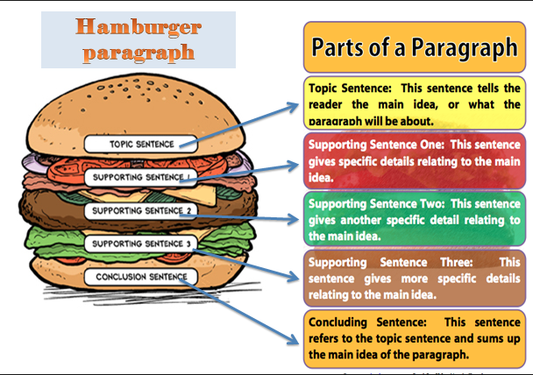

Task 1: Read the two paragraphs below. Which one is a better paragraph? Why?

Paragraph 1

Learning English can help people find better jobs in the UK. Many employers want workers who can speak and understand English well, especially in customer service and office jobs. Also, English skills are often needed to complete job applications, attend interviews, and follow instructions at work.
Therefore, people who improve their English can apply for more jobs and may be offered higher pay or promotion. For this reason, many people attend English classes to improve their chances in the job market.

Paragraph 2

Learning English can help people find better jobs in the UK. In fact, many people move to the UK for a better life. This may be because The UK has several different types of weather in each season. For example, it could be rainy, windy and sunny at the same time. Furthermore, some people go to college to study. Studying English at college can be a very rewarding experience and people can improve their skills there. Overall, it is also important to eat healthy food and exercise

- Better paragraph

- Why?

Task 2: Write three supporting ideas for the following topic sentences.
- Mobile phones have changed the way people communicate and spend their time.
1.______________________________________________________________________
2. ______________________________________________________________________
3. ______________________________________________________________________
- Fast food is popular because it is cheap and convenient, but it is often unhealthy.
  - ___________________________________________________________________
  - ___________________________________________________________________
  - ___________________________________________________________________
- Learning English opens up more job opportunities for people in the UK.
  - ___________________________________________________________________
  - ___________________________________________________________________
  - __________________________________________________________________

- Recycling helps protect the environment by reducing waste and saving energy.
  - __________________________________________________________________
  - __________________________________________________________________
  - __________________________________________________________________
- There are several ways I like to relax in my free time.
  - __________________________________________________________________
  - __________________________________________________________________
  - __________________________________________________________________

Task 3: Now choose one and write a complete paragraph below:

Writing AC 2.3 The Concluding Sentence
Some paragraphs end in a concluding sentence, but they are not necessary for every type of paragraph.
Depending on your writing task (formal email/letter, article) and its purpose (to advise, complain, give your opinion, discuss pros and cons etc.) there are six ways to write a concluding sentence:
- Restate (paraphrase) the topic sentence.
- Summarise the key points in the paragraph.
- Offer a final thought – give your opinion.
- Make a prediction based on the details of the paragraph.
- Make a recommendation based on the details of the paragraph.
- Transition into the next paragraph.

Task 1: Read the paragraph below. Look at the list of concluding sentences (a - f), and decide what type is being used from the list above (numbers 1-6).

Learning English can help people live more confidently in the UK. This is because many people need English to talk to doctors, teachers, or neighbours. Furthermore, It also helps with finding work, using public services, and making new friends. In fact, people who speak English well often feel more independent and included in society. For this reason, many people take English classes or practise speaking every day.

Concluding Sentences (One for Each Type)

- Being able to speak English clearly helps people feel more confident and in control of their lives in the UK.
- In short, English helps with work, daily life, and building social connections in the UK.
- In my opinion, learning English is one of the most important steps to a better life in a new country.
- As more people continue to learn English, they will find it easier to succeed and feel part of the community.
- For anyone living in the UK, I would recommend joining an English class to improve your confidence and communication skills.
- Another important part of living in the UK is understanding how to use the healthcare system.

Task 2: Now write a paragraph on a topic from the list below. Make sure you include a topic sentence, supporting sentences and a concluding sentence.
- Public transport in the UK
- Learning English
- Weather in Britain
- Shopping in local supermarkets
- Finding a job in the UK
- Living in a shared house
- Celebrating British festivals

Writing AC 2.3: Discourse Markers

Linking phrases/Transitional Words / Discourse Markers/Signpost language - different terms for the same things.

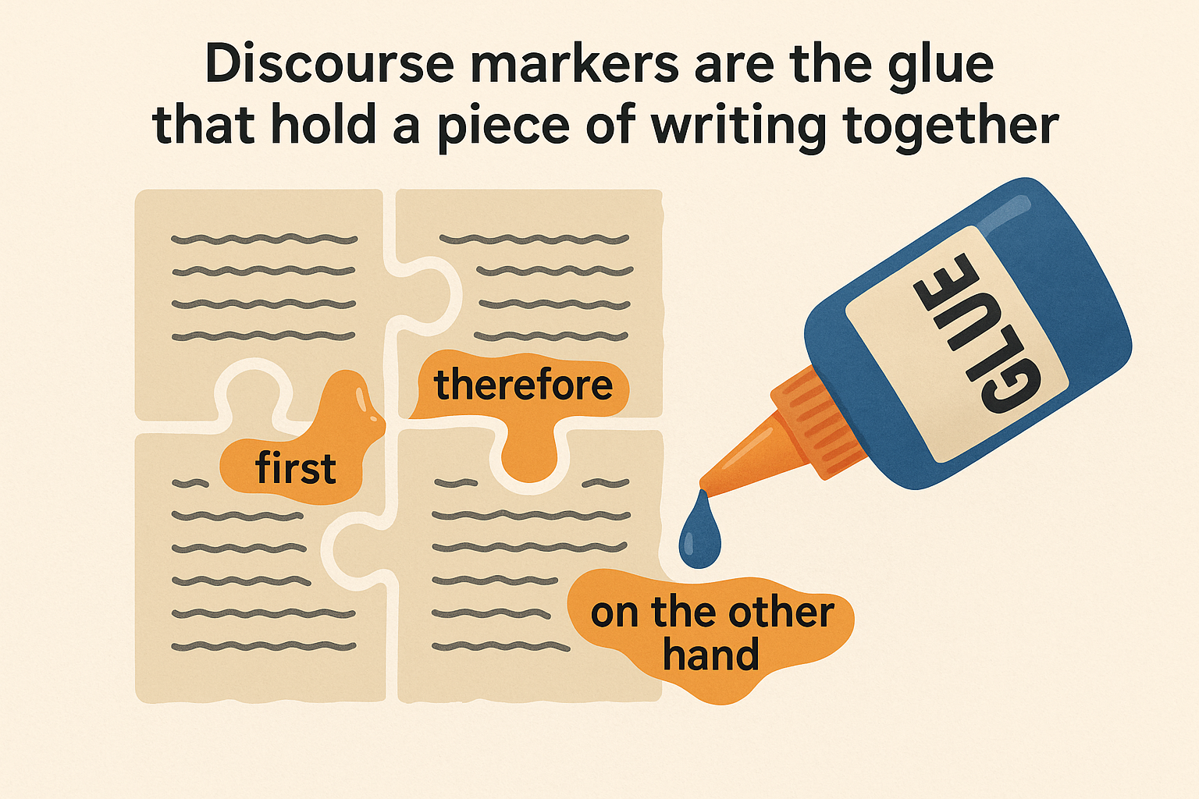
To achieve assessment criterion 2.3, you must write using discourse markers. This gives your writing better structure and flow for the reader.

Discourse markers
Discourse markers can help you guide the reader through your writing and make sure the order is clear and flows well. These are small words or phrases that help the reader follow your argument, understand the relationship between your ideas and predict what’s going to come next.

Task 1: Read the following paragraphs and answer the following questions:
- Which is the better paragraph and why?
- What makes the paragraph different?
- Highlight the words/phrases which show the better paragraph.

- Cardiff Castle is in the centre of Cardiff. It has a long history. It was originally a Roman fort. It became a Norman castle. The castle was used by many important people. Today it is open to the public. You can visit the rooms. You can walk on the castle walls. It is a popular tourist attraction. Many people go there every year.

- Cardiff Castle is located in the centre of Cardiff. To begin with, it was built as a Roman fort. Later, it became a Norman castle. Over the centuries, it was used by many important people. Today, the castle is open to the public. For example, you can explore the beautifully decorated rooms. In addition, you can walk along the castle walls. As a result, it is one of the city’s most popular tourist attractions. Every year, many people visit to learn more about its fascinating history.

Discourse markers show the relationship between paragraphs or sections of a text or speech. They provide greater cohesion (unity) by making it more explicit or signalling how ideas relate to one another. They identify when:

- Ideas are being listed
- Additional ideas are being introduced
- The next idea is working in contrast with the previous idea
- Examples are being given
- Showing cause and effect
- The writer wants to emphasis an idea
- A paragraph or text is ending

Task 2: Each paragraph is missing discourse markers. Read the texts carefully and add the missing discourse markers.
1. Sports
____, playing sports is a great way to stay healthy. ____ it helps to reduce stress. ____ many people do not find the time to exercise. ____ making sport a regular part of your routine can improve your physical and mental health. ____ some people prefer individual sports, others enjoy team activities. ____ sports are a fun way to meet new people and stay fit.
  - overall
  - while
  - nevertheless
  - however
  - in addition
  - firstly

2. Leisure time
People spend their free time in different ways. ____ some enjoy quiet activities like reading, others prefer going out with friends. ____ it is important to have a balance between work and relaxation. ____ doing something enjoyable can help you feel more motivated. ____ it can improve your overall well-being. ____ everyone should find time for leisure in their busy lives.
- for example
- while
- therefore
- in conclusion
- furthermore

3. Recycling
Recycling helps to protect the environment. ____ it reduces the amount of waste in landfills. ____ it saves energy and natural resources. ____ some people still throw recyclable items in the bin. ____ more awareness is needed. ____ if we all recycle properly, we can make a big difference.
- however
- overall
- for instance
- as a result
- furthermore

4. Reading
Reading for fun has many benefits. ____ it improves your vocabulary and writing skills. ____ it helps you to relax. ____ some people say they do not have time to read. ____ making time for reading every day can have a positive effect. ____ reading is a cheap and enjoyable hobby.
- in short
- in addition
- even so
- firstly
- however

5. Social media
Social media is used by millions of people. ____ it helps people stay connected. ____ it allows users to share news and ideas quickly. ____ there are also some negative effects. ____ people can become addicted to scrolling online. ____ it is important to use social media responsibly.
- for example
- on the one hand
- moreover
- on the other hand
- therefore

Task 3: Read the following paragraphs and fill in the most appropriate discourse markers in each paragraph. When you finish, compare with a partner? Are they the same?
- Good students have three important qualities. ____________ they attend all the classes regularly. When they are in class, they also participate in class activities and discussions. __________, they study really hard. They have a regular study plan. They do homework and revise newly learned grammar points and vocabulary items regularly. _________, they are always motivated and ready to learn. Because they have set certain goals, they try to motivate themselves to be successful all the time. They never give up. ____________, a good student attends classes regularly, studies really hard and is always motivated.
- There are several disadvantages of using mobile phones in class. __________, mobile phones distract students. Students may text their friends, play games or browse the Internet during class, so they don’t pay attention to their teachers. _________, when their phones ring or vibrate, it also distracts the teacher and other students in class. It disturbs the class atmosphere and learning. ___________, students may use their mobile phones during quizzes or in-class writing assignments. When they have Internet access, they may look up answers on the Internet. ________, using mobile phones in class has some negative effects.

- Learning another language opens many doors. ____________ it can help you find a better job. __________ it allows you to speak with people from other cultures. _______________ if you are living abroad, it can help you to settle into a new country. __________ learning a new language takes time and effort. _____________ the benefits are worth it. ___________ it can improve your travel experiences and boost your confidence.

Task 4: Write the discourse markers from paragraphs 1-6 correctly in the chart below.
Time | Examples | Listing/adding | Contrast
Cause and Effect | Emphasis | Summary / conclusion

Task 5: Compare your chart with your partner’s. Look online. Can you add more discourse markers to the chart above?

Task 6: Fill the gaps below with the words/phrases from the box.
additionally on the positive side for example in conclusion especially
although however while

Working Abroad: A Life-Changing Experience?
In recent years, many people have chosen to work abroad. _________ this decision can bring great benefits, it may also involve serious challenges. This essay will explore both the advantages and disadvantages of working in a foreign country.
________________________________, working abroad can help people develop new skills and experiences. It often improves language ability and cultural understanding. ________________, if someone works in another country, they may learn how to adapt to different ways of thinking and working. ____________________, some jobs abroad offer better salaries and career progression.
___________________, there are also disadvantages to consider. People might feel lonely or homesick, ______________if they are far from their family. It can also be difficult to adjust to a new culture or climate. In some cases, workers have been treated unfairly or given less support than locals. If they had researched the country better, they might have avoided some problems.
___________________, working abroad can be a rewarding but challenging experience. _________it may help personal and professional growth, it can also be stressful and isolating. In my opinion, it is important to plan carefully and be open-minded in order to succeed in another country.

Writing AC 2.4 Simple Sentences
To achieve AC 2.4, you must use a range of simple, compound and complex sentences.
What is a simple sentence?
One piece of information with a full stop at the end. A simple sentence consists of only one clause. It has a subject and only one verb. It must be a complete thought.
I study English.
Subject + Verb + Object
It can also be referred to as an independent clause.

- Simple sentences can list items:
e.g. I speak English, French and Spanish.

- Simple sentences can have a compound subject:
e.g. Khaled and Asim went into town.

- Simple sentences can include place and time:
e.g. I study ESOL at Cardiff and Vale College on Mondays and Wednesdays every week.

- Simple sentences can include all other parts of speech:
e.g. The lonely old man slowly walked down the long, winding path through the dark forest.

- Simple sentences can include coordinating conjunctions and, but and or:
e.g. I love fish and chips.
e.g. I love fish but not chips.
e.g. Would you like fish or chips?

Simple sentences cannot include more than one verb, subordinating conjunctions, dependent or subordinate clauses.

Task 1: Develop the following simple sentences so they include:
- Listing items
At the weekend he plays football.
__________________________________________________________________________
- Compound subjects
Maryna didn’t finish her homework.
_____________________________________________________________________________

- Place and time
I went to the cinema
_____________________________________________________________________________
- Other parts of speech (articles, adjectives, adverbs, prepositions)
The dog sat on the grass
_____________________________________________________________________________
- Conjunctions and, but and or
She exercises
______________________________________________________________________________
Task 2: Write 10 of your own simple sentences that include:
- Listing items
- Compound subjects
- Place and time
- Other parts of speech (articles, adjectives, adverbs, prepositions)
- Conjunctions and, but and or
- Different tenses

Writing AC 2.4 Compound Sentences

A compound sentence has at least two independent clauses, and they are separated by a comma and a coordinating conjunction:
independent clause + , coordinating conjunction + independent clause
See how these simple sentences (independent clauses) become a compound sentence:
Simple Sentences
I study English.
Subject + Verb + Object
My wife studies French.
Subject + Verb + Object
Compound Sentence
Two pieces of information balanced either side of a coordinating conjunction.
I study English, but my wife studies French.
Subject + Verb + Object +, Coordinating conjunction + Subject + Verb + Object
What are independent clauses?
An independent clause contains a subject and a verb. It can stand by itself as a sentence.
Task 1: Which of the following sentences are simple sentences, and which ones are compound sentences?
- The presentation was interesting but very long.
- The presentation was interesting, but it was also very long.
- I want to be successful, and I want to be famous. _______
- I want to be successful and famous. _______

Task 2: Identify which of the sentences are simple, and which are compound.
- I ate lunch, but I skipped breakfast.
- I want to go to France but not this year.
- I want to travel to Barcelona and Madrid.
- The moon is bright, and the stars are out.
- So far, so good.
- I woke up late, so I missed my bus.
- I’m going to London for a week or so.
- I revised for the test, yet I still failed.
- I haven’t eaten, nor have I drunk anything.
- I must finish this assignment for university.
- I didn’t go to work yesterday, for I was ill.
- He eats nothing but chicken and chips.
Please note: Some conjunctions are also other parts of speech.
Task 3: Which part of speech are the words in bold?
- For is both a conjunction and preposition.
I’m going to Manchester for a week or so.
I didn’t go shopping yesterday, for I was tired.

- But is a conjunction and preposition.
I ate breakfast, but I skipped lunch.
He eats nothing but chicken and chips.

- Yet is both a conjunction and an adverb.
I was up early, yet I still missed the bus.
Have you done it yet?

- So is both a conjunction and an adverb.
So far, so good.
I woke up late, so I missed my bus.

Coordinating conjunctions
There are 7 coordinating conjunctions you can use when connecting two independent clauses. FANBOYS is an acronym to help us remember the 7 coordinating conjunctions.
Task 4: Which conjunction does each letter represent? Write it on the line.

F
A
N
B
O
Y
S

Each coordinating conjunction is used differently and has a different purpose. Each creates a different relationship between clauses.

Task 5: Match the purposes in the box with the correct coordinating conjunction in the chart.
To show contrast To add information To give a choice To show result
To add negative information To show reason To show contrast
 | Conjunction | Purpose | Example
 | For |  | I went to bed early, for I was exhausted.
 | And |  | I went to bed late, and I got up late.
 | Nor* |  | *I didn’t go to bed late, nor did I get up late.
 | But |  | I went to bed late, but I woke up early.
 | Or |  | I might go to bed early, or I may stay up late.
 | Yet |  | I went to bed early, yet I am still tired.
 | So |  | I went to bed early, so I have lots of energy today.

(*after “nor” in a compound sentence the word order changes to a question word order)

Task 6: Match the first independent clause with the second to make a compound sentence.

- I wanted to go to the beach, for she ate all the cakes!
- I will mow the lawn today, and my sister plays football.
- She is practising grammar, nor is it a member of NATO.
- They went to the supermarket, or I will do it tomorrow.
- I play tennis, yet they forgot to buy tea bags.
- She must have been starving, but it started raining.
- Serbia is not in the European Union, so she should pass her exams.

Task 7: Join the pairs of simple sentences together to make compound sentences. Choose carefully which of the FANBOYS conjunctions you will use.

for and nor but or yet so

Owen went to the shops. He bought some bananas.

Mo doesn’t like playing football. He doesn’t like to play basketball.

Michelle is great at all sports. She is unable to swim.

You didn’t eat your mushrooms. You didn’t finish your broccoli.

You must remember your student ID card. You cannot enter the building.

The computer had a virus. I lost all my data.

Eric walked slowly. He had hurt his ankle.

Task 8: Write 7 of your own compound sentences. Use all seven coordinating conjunctions and punctuate each sentence correctly.

Writing AC 2.4 Complex Sentences
What is a complex sentence?
A complex sentence has a main (independent) clause and a subordinate (dependent) clause, which are connected by a subordinating conjunction.

Two or more pieces of information. One relies on the other(s) to make sense.
I am trying my best although I find English grammar difficult.

independent clause + subordinate conjunction + dependent clause
In the complex sentence example above, the independent clause comes first. A clause is a group of words that has a subject and verb. An independent clause can stand alone as a complete sentence.
- I am trying my best.
A dependent clause does not express a complete thought, so it is not a sentence. It cannot stand alone and must be used with an independent clause.
- Although I find English grammar difficult.

The independent clause and the dependent clause are interchangeable; either can come first. In the complex sentence below, the dependent clause comes first.

Although I find English grammar difficult, I am trying my best.

subordinate conjunction + dependent clause, + independent clause

Dependent clauses always start with a subordinating conjunction.
If the dependent clause comes first, place a comma between it and the independent clause.

Task 1: Read each clause in the chart. Discuss with your partner and decide if each is independent or dependent.

 | Independent clause | Dependent clause
- When he arrived
- She enjoys reading books
- If you had studied more
- After the storm passed
- You could have passed the exam
- The sun came out
- The party was in full swing
- That are set in the past

Task 2: Identify which of the sentences are simple, compound, and complex sentences.
1. a. Rhys looked at Claire.
b. Rhys looked at Claire, but Claire did not look at Rhys.
c. Rhys and Claire looked at each other when they met.
2. a. Tom studies Arabic, and James speaks Chinese.
b. Tom met James when they were at university.
c. James studied Chinese and spoke it in Beijing.
3. a. Hugh felt depressed, so he stayed in bed.
b. Hugh and Seren argued today.
c. Hugh is sad because he argued with Seren.
4. a. Satoshi bowed to Noriko when they met.
b. Satoshi and Noriko bowed to each other.
c. Noriko introduced herself, and Satoshi bowed.

Task 3: Read the paragraphs below. Identify the simple, compound and complex sentences.
Paragraph 1
Welsh is one of the oldest living languages in Europe. (_____________) It is spoken by thousands of people in Wales today. (___________) The government encourages its use in schools, so more young people are learning it. (____________) Many road signs, official documents, and TV programmes appear in both English and Welsh. (______________) Although some people find it difficult to learn, they often feel proud to speak it. (__________) Welsh is more than just a language, for it is a symbol of identity and history. (____________) When people speak Welsh, they feel connected to their roots. (____________) In some areas, it is spoken every day at home, at work, and in the community. (___________) The language is protected by law, which helps it to survive. (__________) Because of this, the future of Welsh looks bright. (____________)

Paragraph 2
Wales is known as the “Land of Song.” (_________) Music plays a big part in Welsh culture. (________) People of all ages enjoy singing, and choirs are popular in many towns and villages. (___________) One of the most important cultural events in Wales is the Eisteddfod. (__________) This is a traditional festival where people compete in music, poetry, and performance. (_____________) The Eisteddfod celebrates Welsh language and talent, and it brings communities together. (______________) If you travel in Wales during the summer, you might be able to attend this exciting event. (___________) Both children and adults take part, which helps to keep the tradition alive. (__________) People wear traditional clothes, and the winning poets are given special chairs. (____________) Welsh music and festivals are really fun, and they help people feel proud of their culture. (___________)

- Number of complex sentences
- Number of simple sentences
- Number of compound sentences

Task 4: Read the following complex sentences. Highlight the conjunctions and underline the independent clauses.

- Although many people support the proposal, some residents have raised concerns about its long-term impact on the community.
- The manager postponed the meeting because several key staff members were unavailable.
- If the application is not submitted on time, you may lose the opportunity to take part in the programme.
- We decided to continue with the project even though the funding had been reduced significantly.
- While the course offers useful content, some learners feel that the pace is too fast.
- The government introduced new policies in order to reduce carbon emissions and promote renewable energy.
- Unless more support is provided, small businesses may struggle to recover from the economic downturn.
- When customers feel valued, they are more likely to return and recommend the service to others.
- Since technology has become essential in education, teachers must adapt their methods to meet modern needs.
- Even if the weather improves tomorrow, the event may still be cancelled due to safety concerns.

Subordinating conjunctions

Subordinating conjunctions are used to make complex sentences.
- Unlike coordinating conjunctions, there are many subordinating conjunctions.
- Subordinating conjunctions are used to connect clauses within complex sentences and to create a relationship between them.
- The role of a subordinating conjunction and the dependent clause is to establish a condition, a concession, a comparison, time, a place, or a reason for the independent clause.

- Comparison
These words or phrases link the dependent and independent clauses by comparing the two of them:
- John liked chicken whereas Emma preferred fish.
- Someone must go first, whether it’s you or me.

- Contrast
These words or phrases link the dependent and independent clauses by showing a contrast between them:
- Although I’m going to school, I’d much rather stay home and watch TV.
- Sally is heading to the football match today despite the rain.

- Condition
These connect the dependent and independent clauses by showing that the main idea relies on the supporting information:
- Unless you tidy your room, you’re not going on the PlayStation.
- Peter didn’t want to take the train in case it was delayed.

- Time
These connect the two clauses together by showing a time relationship between the two of them:
- After he finished his exams, he felt relaxed and happy.
- Eden made it to the front of the queue before they ran out of food in the canteen.

- Place
These words connect the clauses together by showing a position or place:
- The robbers hid the jewelry where nobody could ever find it.
- Wherever possible, you should avoid using single use plastic bags.

- Reason
These words provide a reason or an explanation as to why something happened:
- Because the taxi was late, she missed her appointment.
- Robin arrived late so that he wouldn’t have to see his manager.

Task 1: Look at the subordinating conjunctions in the table below. Categorise them correctly using the chart. Can you add any more that you know?

while | till /until | although | because
where | if | as | whereas
when | even though | since | wherever
unless | after | though | so that
everywhere | provided that | rather than | before
despite | in order that / to | once | whether
even if | whenever

Comparison | Time | Contrast
Reason | Condition | Place

Task 2: Although, since and while have more than one purpose. Look at the examples below and decide on the relationships between the independent and dependent clauses.

  - Although can be used to show comparison or contrast.

- Although Ewan wasn’t feeling well, he managed to get all his work done. ______
- This jumper is a good colour, although that one is a better fit. ______

  - Since can be used to show time or reason.

- Since September, I have been going to the gym regularly. _____
- Since you’ve cooked the dinner, I’ll do the washing up _____

- While can be used to show time, comparison and concession.

- While some people find gardening boring, I enjoy growing various flowers.
- While I was in Manchester, I visited several famous landmarks.
- While I appreciate what you’re saying, I'm afraid I have to disagree.

Task 3: Choose the best option for the following sentences. 🎵 🎵 🎵

- I always listen to music (although / because) it helps me concentrate when I study.
- She couldn’t hear the announcement (until / if) the music was turned down.
- I enjoy listening to jazz (whereas / unless) my brother prefers heavy metal.
- We missed the beginning of the concert (because / even though) the traffic was terrible.
- He continued playing the guitar (while / even though) his fingers were sore.
- I won’t go to the music festival (unless / although) it stops raining.
- She practices the piano every day (so that / if) she can pass her music exam.
- We couldn’t record the song properly (because / in case) the microphone was broken.
- My friend plays in a band (even though / so that) she can meet new people.
- I downloaded the music app (while / because) my teacher recommended it.

Task 4: Write 6 of your own complex sentences. Write a sentence for each of the following categories, ensuring you punctuate your sentences correctly.
Time

Place

Reason

Condition

Comparison

Contrast

Writing AC 2.4 Using Sentence Variety
When you write, it’s important to use a range of simple, compound and complex sentences. Using different sentences makes your writing more interesting.
Task 1: Read two paragraphs below and tick the better paragraph.
Paragraph 1
I went to a beach in The Gower. The weather was sunny. The sand was soft. The sea was blue. Many people were swimming. Some children were building sandcastles. I ate fish and chips. I drank lemonade. I saw a lifeguard. He was watching the sea. A dog was running along the sand. The waves were small. A family had a picnic. I took some photos. I sat on a towel. I read a book. I stayed for two hours. I walked back to the car. I felt tired. I had a great day.
Paragraph 2
Last weekend, I visited a beautiful beach in The Gower. Although the weather forecast predicted rain, it turned out to be sunny and warm. The sand was golden and soft, so we took off our shoes and walked along the shore. While some people went swimming, others relaxed with a book or built sandcastles. In addition, I enjoyed delicious fish and chips with a cold lemonade. Afterwards, we took photos of the view because the light was perfect. Eventually, we packed up and walked back to the car. Overall, it was a peaceful and enjoyable day by the sea.

Task 2: Give two reasons for your choice.
- ______________________________________________________________________________
- ______________________________________________________________________________
Task 3: Rewrite the paragraph below. Use a range of simple, compound and complex sentences. Add discourse markers, conjunctions, adverbs and adjectives to make it as interesting as possible.
My recent trip to St Fagan’s Museum
I went to St Fagan’s Museum last weekend. I took the bus from the city centre. The journey was short. The weather was cold. I wore a coat and hat. I arrived at the museum in the morning. I looked at the old houses. I walked through the gardens. I saw animals on a farm. I took some photos. I had lunch in the café. I bought a postcard from the shop. I enjoyed my trip. I want to go back again. The museum was interesting. It showed a lot of Welsh history.

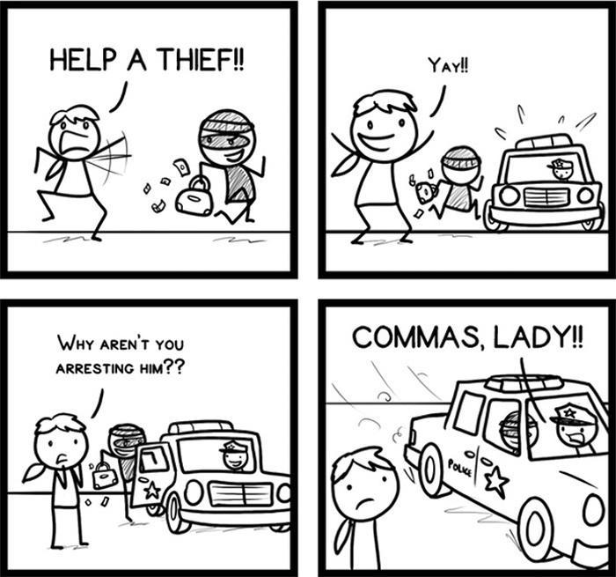
Writing AC 2.5 Correct Punctuation
To achieve this assessment criterion at Level 2 you must correctly punctuate at least seven sentences. You must also be able to include a range of punctuation marks appropriate to the task and level.
Task 1: Fill in the chart below with the correct punctuation marks.

 | Punctuation | Example | Use
 | Question mark | ? | At the end of a direct question
 | Exclamation mark
 | Colon
 | Semi-colon
 | Speech marks
 | Brackets
 | Apostrophes for contractions
 | Apostrophes for possessives
 | Commas
 | Bullet point
 | Hyphen
 | Dash

Task 2: Add the use of each punctuation mark from the list below to the table above.
  - To make lists clearer and easier to read.
  - To link two closely related ideas OR to separate items in a complex list
  - To show something belongs to someone.
  - To show missing letters in informal writing.
  - At the end of a direct question
  - To join words in compound adjectives or compound nouns.
  - To add extra information.
  - To show strong emotion or surprise.
  - To introduce a list, explanation, or quotation.
  - To show direct speech.
  - To separate items in a list, after linkers, or to clarify meaning
  - To add emphasis or an extra comment.
Task 3: Add question marks or exclamation marks to the sentences below.
e.g. What time does the lesson start?
- I can’t believe it
- Do you like pizza
- Be careful
- That was fantastic
- Where is my phone
Task 4: Add colons or semi-colons to the sentences below.
e.g. I like apples; they are sweet.
e.g. There are four UK capitals: Cardiff, London, Edinburgh and Belfast.
- I like bananas they are delicious
- There are three types of rock sedimentary, igneous, and metamorphic
- She had one goal become a teacher
- She travelled to three cities Cardiff Belfast and Edinburgh
Task 5: Add speech marks to the sentences below.
e.g. He said, “I’m going home.”
- I love music said John
- What time is it she asked
- She asked Where are we going
Task 6: Add brackets to the sentences below.
e.g. The meeting is on Monday (a bank holiday).
- She moved to London the capital city last year
- I’m meeting Tom my cousin for lunch
- My sister who is a talented musician is studying abroad
- I need to buy groceries including milk eggs and bread
Task 7: Rewrite the sentences below using apostrophes for either contraction or possession.
e.g. Jane’s coming next week.
e.g. Jane’s bag is on the floor.
- I cannot see you now. ____________________
- I am very tired. _____________________
- They have already been _____________________
- The coat of John ______________________
- The toys of the children ______________________
- The room of my parents _______________________
Task 8: Add commas where needed
e.g. I like apples, oranges and bananas.
e.g. First, wash your hands.
- On Monday Tuesday and Friday we have class
- However I didn’t agree with her
- In Antarctica there is lots of snow ice and water.
- The snow is white cold and beautiful.
- I watched the penguins as they wobbled walked squawked and cuddled together.
Task 9: Turn the sentences into bullet point lists:
e.g. I visited my friend and we played:
- computer games
- football
- a board game
- chess
- the piano
- You will need trainers, a water bottle and a packed lunch.
- You need to bring a pen, a notepad and a dictionary.
- Humans have five senses which are sight, smell, hearing, touch and taste.

Task 10: Add hyphens where necessary.
e.g. second-hand clothes
- He has a part time job _____________________________________________
- He is a full time student _____________________________________________
- She is a well known artist _____________________________________________
- You are a five year old child _____________________________________________
Task 11: Add dashes where necessary.
e.g. She brought everything she needed – food, drinks, and a blanket.
- I loved the concert it was unforgettable
_________________________________________
- She’s my best friend always honest and kind
____________________________________________
- I was tired I hadn’t slept all night
____________________________________________
- We need to hurry we’re going to be late
____________________________________________
Task 12: Punctuate the following text correctly last saturday my friend emily and i went to the food festival in cardiff we arrived at 11 am and the place was already busy people were walking around with plates of delicious food music was playing and the smell of spices was everywhere we tried food from india mexico and Thailand emily said i want to try the mango curry it smells amazing we queued for ten minutes and finally got some it was spicy but very tasty afterwards we listened to a cooking demonstration the chef said always taste your food as you cook it helps you get the flavour just right i took some notes because i want to try his recipe at home we stayed for three hours we bought fresh bread cheese and olives from a stall and we drank homemade lemonade we were tired by the end but it was worth it what a brilliant day on the way home emily asked shall we go again next year i said definitely but next time lets bring some containers so we can take food home

Writing AC 2.6 Spelling
To achieve this assessment criterion, you must spell common words, technical words and key words correctly.
Use the chart below to help you practice any spelling errors you may have.

Spelling Practice Chart
Use this chart to write down and practice words you commonly misspell.
Look/Say | Write / Check | Write / Check | Write / Check | Write / Check

Further Practice Task 1 Form

Task: You want to apply for an apprenticeship programme. Complete the following form.

Apprenticeship Application Form
Section 1 – Personal Details
Please complete the form in full.
Full name: _____________________________________________
Date of birth: ___ / ___ / ______
Home address: _____________________________________________

Postcode: __________________
Telephone number: __________________________
Email address: _____________________________________________
National Insurance number (if known): _________________________

Section 2 – About You
Answer the following questions. Circle, tick, delete or underline as instructed.
- What type of apprenticeship are you applying for?
☐ Business Administration
☐ Construction
☐ Digital Marketing
☐ Health and Social Care
- When are you available to start the apprenticeship?
☐ Immediately
☐ In 1 month
☐ In 3 months
☐ Next year
- Do you have any previous experience in this area?
☐ Yes
☐ No
- Please tick the qualifications you currently hold:
☐ GCSEs or equivalent
☐ A-Levels or equivalent
☐ BTEC/NVQ
☐ Degree
☐ None
- What is your current employment status?
☐ Employed full-time
☐ Employed part-time
☐ Unemployed
☐ Student
- Do you have a full UK driving licence?
Delete as appropriate: Yes / No

Section 3 – Written Responses
Please answer the following questions in full sentences. Write at least 3–5 sentences for each question.
1. Why are you interested in this apprenticeship, and what do you hope to gain from it?

2. Describe any skills or qualities you have that would make you a good apprentice.

3. What are your future career goals?

Further Practice: Task 2 Formal letter

Writing Task: You are unhappy about the condition of your local park (rubbish, broken playground equipment, a lack of litter bins, etc.).
Write a letter to your local MP complaining about the issues and suggesting what could be done. You must write at least 220 words.
Task 1: Understanding the Model Letter. Read the model letter and answer the questions below.
Sofia Koval
3, Penny Lane, Cardiff
CF23 4SL
skoval45@gmail.com
3/07/25
Jo Stevens, MP 116 Albany Road
Roath
Cardiff
CF24 3RU
Dear Jo Stevens,
I am writing to express my concern about the poor condition of Roath Park in our local area. As a long-standing resident and regular visitor, I am increasingly alarmed by the state of the park, which has sadly become neglected and unpleasant for families and local residents.
Firstly, there is a serious litter problem. Rubbish is often left scattered around the park, especially near the benches and play areas. The situation is made worse by the fact that there are very few litter bins available, and those that exist are often overflowing. Secondly, much of the playground equipment is broken or unsafe. Several swings are missing seats, and one of the climbing frames has been damaged for months without repair.
This situation not only poses a safety risk for children but also discourages families from using the park. If action is not taken, the park will continue to deteriorate and could become a hotspot for antisocial behaviour.
I would like to suggest that the council carries out regular maintenance checks, installs more bins throughout the park, and repairs damaged equipment as a priority. Signs encouraging people to keep the park clean could also make a difference.
I hope you will raise this issue with the local council and support efforts to improve our community space. I would be happy to discuss this further if required.
Yours sincerely,
Sofia Koval

- Who is the letter addressed to?
→ _______________________________________
- What are the three main problems mentioned in the letter?
a) ______________________________________
b) ______________________________________
c) ______________________________________
- What solutions does the writer suggest?
→ _______________________________________
→ _______________________________________
→ _______________________________________
- Is this letter formal or informal? What language features show this?
→ _______________________________________

Task 2: Complete the plan below.
Purpose:
- _______________________________________________
- _______________________________________________
- ________________________________________________
Paragraph 1: Introduction
- Why are you writing? _______________________________________________
- Where is the park? ________________________________________________
Paragraph 2: Problems
- _______________________________________________________
- _______________________________________________________
- _______________________________________________________
- ________________________________________________________
Paragraph 3: Suggestions
- ________________________________________________________
- ________________________________________________________
- ________________________________________________________
- ________________________________________________________
Paragraph 4: Conclusion
- Request _________________________
- Offer ____________________________
- Sign off formally/informally

Task 3: Grammar and Structure Focus
A. Complete the sentences using formal language and modal verbs (must, should, could, would, etc.):
- The council __________ take urgent action to improve the park.
- More litter bins __________ be installed to reduce the mess.
- If the equipment is not repaired, children __________ get hurt.
- The park __________ be a safe and welcoming place for families.
B. Rewrite the following into more formal language:
- “There’s loads of rubbish everywhere.”
→ ______________________________________________________
- “The swings are messed up and it’s dangerous.”
→ ______________________________________________________

Task 4: Plan Your Own Letter
Use the prompts below to plan your letter.
Paragraph | Content
1. Introduction | Why are you writing? Where is the park?
2. Problems | What specific issues have you noticed?
3. Suggestions | What do you think should be done?
4. Conclusion | Ask for support or action. Offer to help.

Task 5: Write Your Letter
You are unhappy about the waste collection service in your area. The workers are noisy and leave rubbish in the street. Write a formal letter to your local MP to. Remember to:
- Use formal language
- Include at least 220 words
- Use a range of tenses, sentence types, and correct grammar
- Check spelling, punctuation, and structure
- Include a plan

Write your plan here:

Write your letter here:

Further Practice: Task 3 Article

How to Become More Environmentally Friendly: By Charlotte Willis
Have you ever thought about how to protect our environment? Nowadays, many people are becoming more aware of environmental issues. If you want to live in a greener way, there are several simple things you can do to help protect the planet.
Firstly, reducing waste is an easy and important step. Paper, plastic, and glass can easily be recycled. Also, you should try to avoid products with too much packaging. It is also helpful to bring your own bags when shopping and to buy reusable water bottles instead of single-use ones.
Secondly, try to save energy and water at home. For example, you should switch off lights when you leave a room and unplug chargers that are not in use. Also, you should turn off your TV instead of leaving it on standby mode. Taking shorter showers is another great way to reduce water use.
In addition, using public transport such as electric buses, cycling, or walking instead of driving a car can lower pollution. Although this may not always be convenient, it has a big impact on the environment.
Of course, it is impossible to be perfect, but every small change matters. If we had known about these problems 50 years ago, we could have started to protect the planet sooner. However, by making thoughtful choices each day, we can all help to protect the Earth for future generations.
230 words.

Task 1: Highlight the topic sentences and underline the discourse markers in this text.

Task 2: Now, create a plan for this article. Think about the main idea of each paragraph. Write your plan below:

Task 3: Grammar Focus – Sentence Types Identify whether the following sentences from the article are simple, compound, or complex.
- You can recycle paper, plastic, and glass. ____________
- Although this may not always be convenient, it has a big impact on the environment. ____________
- Taking shorter showers is another great way to reduce water use. ____________
- You should switch off lights when you leave a room, and you should unplug chargers that are not in use. ____________
Task 4: Write your own examples:
- Simple: ___________________________________________________________________
- Compound: _______________________________________________________________
- Complex:__________________________________________________________________

Activity 4: Discussion – Agree or Disagree In pairs or small groups, discuss these statements. Use discourse markers like: “Firstly,” “However,” “In my opinion,” “On the other hand,” “Because of this,” etc.
- Everyone should try to live in an environmentally friendly way.
- Using public transport is better than driving.
- It’s too difficult to change our daily habits to help the environment.
Activity 5: Writing Extension Write a short paragraph (80–100 words) answering this question: “What is one thing you already do – or would like to start doing – to help the environment?”
Use at least:
- Two discourse markers
- One complex sentence

Further Practice: Task 3 Opinion Essay
Task 3 Question:
Young people are only interested in technology and don’t have other interests or hobbies. How far do you agree with this?
Task 1: Understanding the Task
Discuss with a partner:
- What is the topic of the question?
- What do you need to do in your answer?
- What does "How far do you agree?" mean?
Write your thoughts below:

Task 2: Planning Your Answer
A. What is your opinion? (Tick one)
☐ I completely agree
☐ I completely disagree
☐ I partly agree
B. Write down 2 or 3 main ideas to support your opinion:
- (Optional) ____________________________________________
C. Give one example for each idea:
Task 3: Sentence Building Practice
A. Match the sentence types with their definitions:
Sentence Type | Definition
1. Simple | a) One main clause + one or more subordinate clauses
2. Compound | b) One independent clause only
3. Complex | c) Two main clauses joined with and, but, or so
Your answers:
B. Identify the sentence type:
Write S for Simple, Cpd for Compound, and Cpx for Complex.
- Many young people enjoy sports like football and swimming. ___
- Technology is popular, but it is not the only thing young people enjoy. ___
- Although technology is important, young people also enjoy creative hobbies. ___
- Some teenagers prefer reading. ___
- They use apps to create music, and they post their work online. ___
C. Create your own sentences:
Write one sentence of each type on the topic of young people's hobbies.
- Simple: __________________________________________________
- Compound: ______________________________________________
- Complex: _______________________________________________
Task 4: Writing Your Answer
Use your ideas from Part 2 and your sentence skills from Part 3 to write your essay.
Young people are only interested in technology and don’t have other interests or hobbies. How far do you agree with this?

Use this structure to help you:
- Introduction – Say what the issue is and give your opinion
- Body Paragraph 1 – First reason + example
- Body Paragraph 2 – Second reason + example
- (Optional) Paragraph 3 – Different opinion or a balanced view
- Conclusion – Restate your opinion and summarise

Write your plan below

Write your answer below:

Task 5: Swap your writing with a partner. Use this checklist:
✅ Did they answer the question clearly?
✅ Did they give their opinion?
✅ Did they use paragraphs with topic sentences?
✅Did they use discourse markers?
✅ Did they use a mix of sentence types?
✅ Did they give clear examples?
Use the following lined pages for extra writing practice.

©Charlotte Willis 2025

